Mock Test Flow!

What is a Mock Test? 🤔

A Mock Test is like stepping into a mini-theatre where you’re the star of the show 🎭! It’s a role-play situation where you’ll replicate real-life scenarios, and your coach will act as both the merchant and your evaluator, assessing you with a scorecard.

How Does It Work?
For your role, you’ll face 4 rounds of Mock Tests, and your total score will be the average of all 4 rounds. Think of it as your final training boss battle, and you’re here to conquer! 💪

The 4 Mock Test Rounds 🎯

- Welcome Call & Go Live Check-In
- Just like the call samples you’ve studied, you’ll use a Salesforce account and follow the provided script.
Welcome Call |  | Go Live Check In
Scenario | SF Link | Scenario | SF Link
1 | F&B: Link | 1 | F&B: Link
2 | Retail: Link | 2 | Retail: Link
- Your task? Nail the call flow, ask the right questions, and ensure the merchant feels supported.
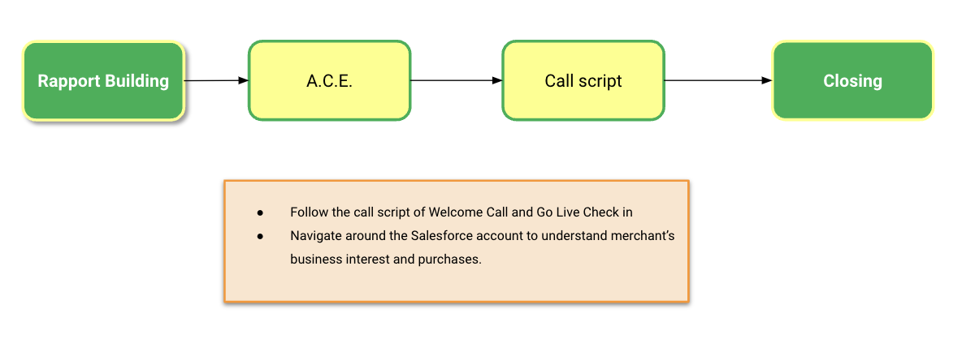

- Training Assessment (F&B and Retail)
- It’s showtime for your training skills!
- You’ll deliver a full onboarding training session (for F&B and Retail) to your coach. Don’t worry, you’ll get a checklist to guide you step by step.

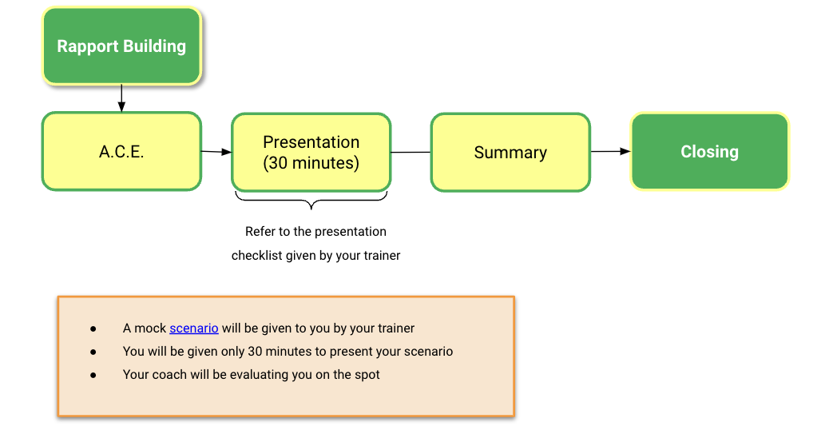

Remember: clarity, confidence, and making it engaging are your best friends here.

Scoring System 📝

By the end of the Mock Test, your coach will average your scores from all 4 rounds. This score is the final checkpoint to prove you’re ready to hit the ground running with merchants!

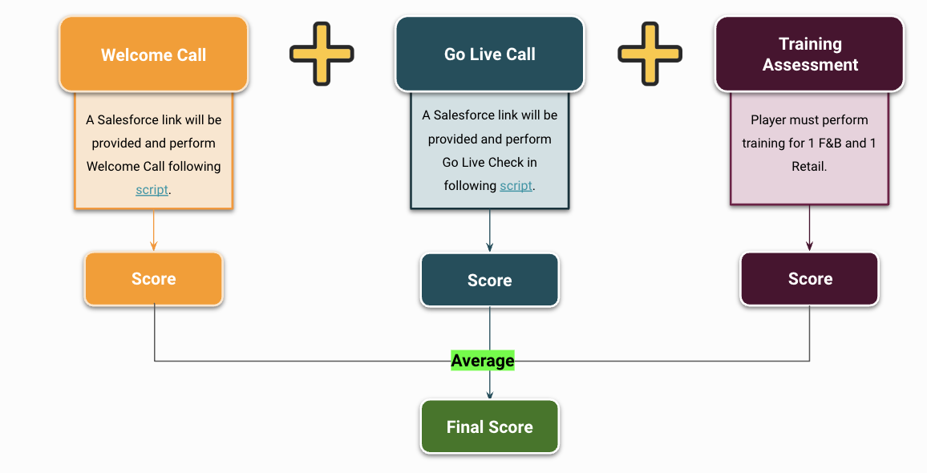

Pro Tip:
Treat every round like a dress rehearsal for the real thing. Prep your scripts, polish your product knowledge, and bring out those soft skills to shine. The more you practice, the more confident and natural you’ll sound.

Go out there and crush it! You’ve got this! 🚀

Player | Mock Type | Assessment Type
Lyn | Welcome Call | F&B: Link
Lyn | Go Live | F&B: Link
Lyn | F&B - Training assessment | 1  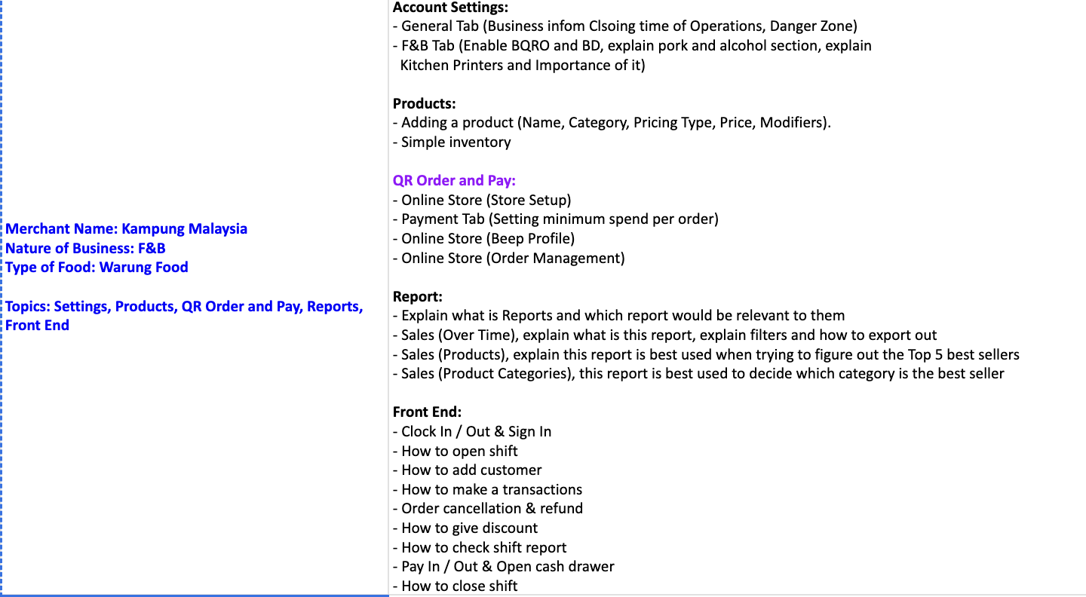
Lyn | Retail - Training Asessment | 2  